 **Appendix 1**

**18/01687/FUL – St Edwards – Corfe Field**

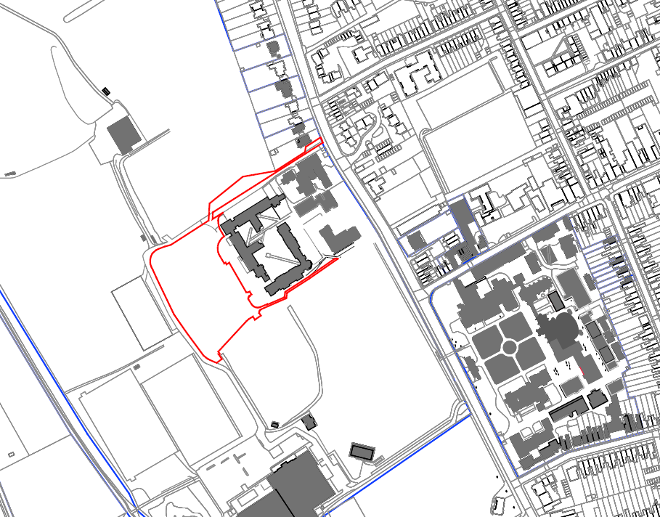

N